**EXPERIMENT 5**

**Aim :**

To prepare Data Flow Diagram for the Application Software – **Bill Management System.**

**Theory :**

**What is Data Flow Diagram ?**

A Data Flow Diagram (DFD) maps out the flow of information for any process or system. It uses defined symbols like rectangles, circles and arrows, plus short text labels, to show data inputs, outputs, storage points and the routes between each destination. Data flowcharts can range from simple, even hand-drawn process overviews, to in-depth, multi-level DFDs that dig progressively deeper into how the data is handled. Like all the best diagrams and charts, a DFD can often visually “say” things that would be hard to explain in words, and they work for both technical and nontechnical audiences, from developer to CEO.

**What are the Components of Data Flow Diagram ?**

* **External Entity :** an outside system that sends or receives data, communicating with the system being diagrammed. They are the sources and destinations of information entering or leaving the system. They might be an outside organization or person, a computer system or a business system. They are also known as terminators, sources and sinks or actors. They are typically drawn on the edges of the diagram.
* **Process :**any process that changes the data, producing an output. It might perform computations, or sort data based on logic, or direct the data flow based on business rules. A short label is used to describe the process.
* **Data Store :** files or repositories that hold information for later use, such as a database table or a membership form. Each data store receives a simple label.
* **Data Flow :** the route that data takes between the external entities, processes and data stores. It portrays the interface between the other components and is shown with arrows, typically labelled with a short data name.
* **Symbols** and **Notations** used in Data Flow Diagram are shown below :

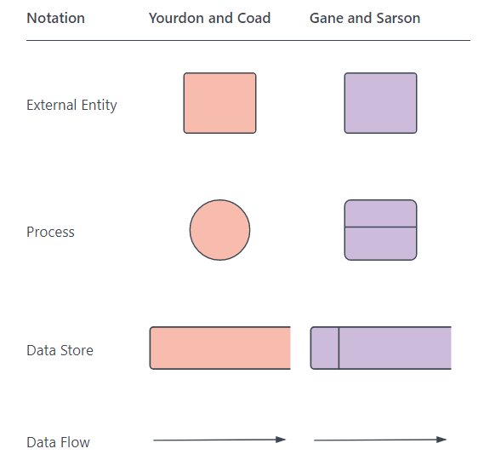

**DFD Rules and Tips :**

* Each process should have at least one input and an output.
* Each data store should have at least one data flow in and one data flow out.
* Data stored in a system must go through a process.
* All processes in a DFD go to another process or a data store.

**DFD Levels and Layers :**

A data flow diagram can dive into progressively more detail by using levels and layers, zeroing in on a particular piece.  DFD levels are numbered 0, 1 or 2, and occasionally go to even Level 3 or beyond. The necessary level of detail depends on the scope of what you are trying to accomplish.

* **DFD Level 0** is also called a Context Diagram. It’s a basic overview of the whole system or process being analysed or modelled. It’s designed to be an at-a-glance view, showing the system as a single high-level process, with its relationship to external entities. It should be easily understood by a wide audience, including stakeholders, business analysts, data analysts and developers.
* **DFD Level 1** provides a more detailed breakout of pieces of the Context Level Diagram. You will highlight the main functions carried out by the system, as you break down the high-level process of the Context Diagram into its sub processes.
* **DFD Level 2** then goes one step deeper into parts of Level 1. It may require more text to reach the necessary level of detail about the system’s functioning.
* Progression to **Levels 3, 4** and beyond is possible, but going beyond Level 3 is uncommon. Doing so can create complexity that makes it difficult to communicate, compare or model effectively.

**Logical DFD vs. Physical DFD**

These are the two categories of a data flow diagram.  A Logical DFD visualizes the data flow that is essential for a business to operate. It focuses on the business and the information needed, not on how the system works or is proposed to work. However, a Physical DFD shows how the system is actually implemented now, or how it will be. For example, in a Logical DFD, the processes would be business activities, while in a Physical DFD, the processes would be programs and manual procedures.

**Conclusion :** The Data Flow Diagrams for the Application Software – **Bill Management System** were prepared successfully.

Data Flow Diagrams for the Application Software – **Bill Management System :**

